NAME : Saraswati Shinde

ROLL NO : D2235011

ENROLLMENT NO : MITU22BTIT0067

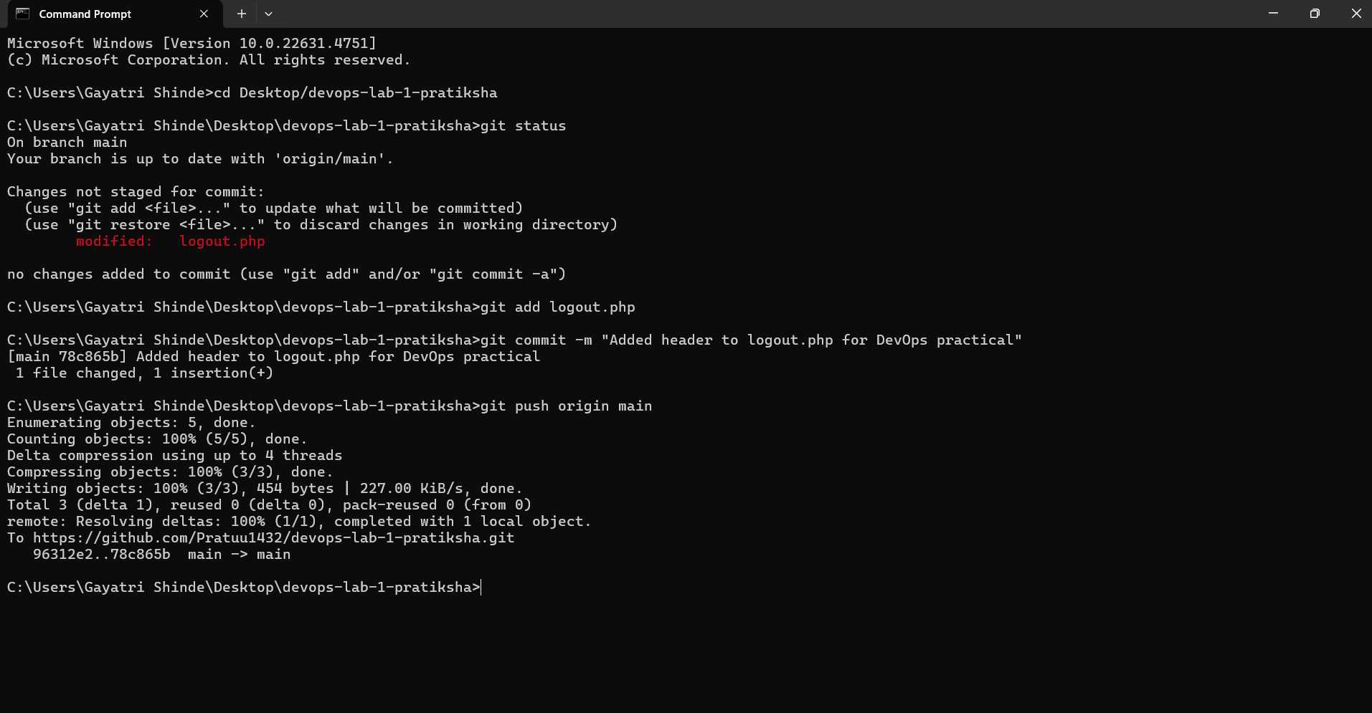

**1. Test Cases for Logout Functionality**

|  |  |  |  |  |  |
| --- | --- | --- | --- | --- | --- |
| **Test Case ID** | **Test Scenario** | **Test Steps** | **Expected Result** | **Actual Result** | **Status (Pass/Fail)** |
| TC_01 | Verify if the logout button is visible | Open the website → Navigate to the dashboard → Check if the logout button is present | Logout button should be visible |  |  |
| TC_02 | Verify successful logout | Click the logout button | User should be logged out and redirected to the login page |  |  |
| TC_03 | Verify session is cleared after logout | Login → Logout → Try to go back using the browser back button | User should not be able to access previous pages |  |  |
| TC_04 | Verify logout from multiple tabs | Open multiple tabs → Logout from one tab → Check other tabs | User should be logged out from all tabs |  |  |
| TC_05 | Verify the logout process when inactive | Login → Stay inactive for a long time → Click logout | User should be logged out successfully |  |  |
| TC_06 | Verify logout functionality on mobile | Open the website on a mobile browser → Click logout | Logout should work on mobile without issues |  |  |
| TC_07 | Verify if logout prevents unauthorized access | Logout → Try accessing a restricted page via URL | User should be redirected to the login page |  |  |
| TC_08 | Verify database session deletion | Logout → Check session table in the database | User session data should be removed from the database |  |  |
| TC_09 | Verify logout performance | Click logout and measure response time | Logout should happen within 2 seconds |  |  |
| TC_10 | Verify UI message after logout | Click logout → Observe the message on the screen | "Logout Successful" message should be displayed |  |  |

**2. Selenium Automation Script for Logout Test Cases**

from selenium import webdriver

from selenium.webdriver.common.by import By

import time

# Set up WebDriver (Make sure chromedriver.exe is in the same folder)

driver = webdriver.Chrome()

# Open the website

driver.get("https://yourwebsite.com/dashboard") # Change this to your actual URL

# Test Case 1: Verify if Logout Button is Visible

try:

logout_button = driver.find_element(By.ID, "logout") # Change 'logout' to the actual button ID

print("\u2705 Test Case 1 Passed: Logout button is visible.")

except:

print("\u274C Test Case 1 Failed: Logout button is not found.")

# Test Case 2: Verify Successful Logout

try:

logout_button.click() # Click the logout button

time.sleep(2) # Wait for redirection

# Verify if redirected to login page

if "login" in driver.current_url:

print("\u2705 Test Case 2 Passed: User successfully logged out and redirected to login page.")

else:

print("\u274C Test Case 2 Failed: Logout did not redirect to login page.")

except:

print("\u274C Test Case 2 Failed: Logout button click issue.")

# Close the browser

driver.quit()  
  
Conclusion

the logout functionality works correctly through 10 test cases and a Selenium automation script. It verifies UI visibility, session management, security, and performance, ensuring a secure and seamless user experience. 🚀